Task 01

**Explanation:**

As per mention in the given Assignment the original data was not normalized it has the functional dependencies and the repeating useless values.  
For Task 01.  
Normalization: I normalize the data and split it into 3 parts the Screenshots are attached below.  
Normalization helps the data to be unique and less messed up.  
Because the same data has been used for many times.  
After Normalization, the Functional Dependencies are reduced.  
  
Here are the evidence: 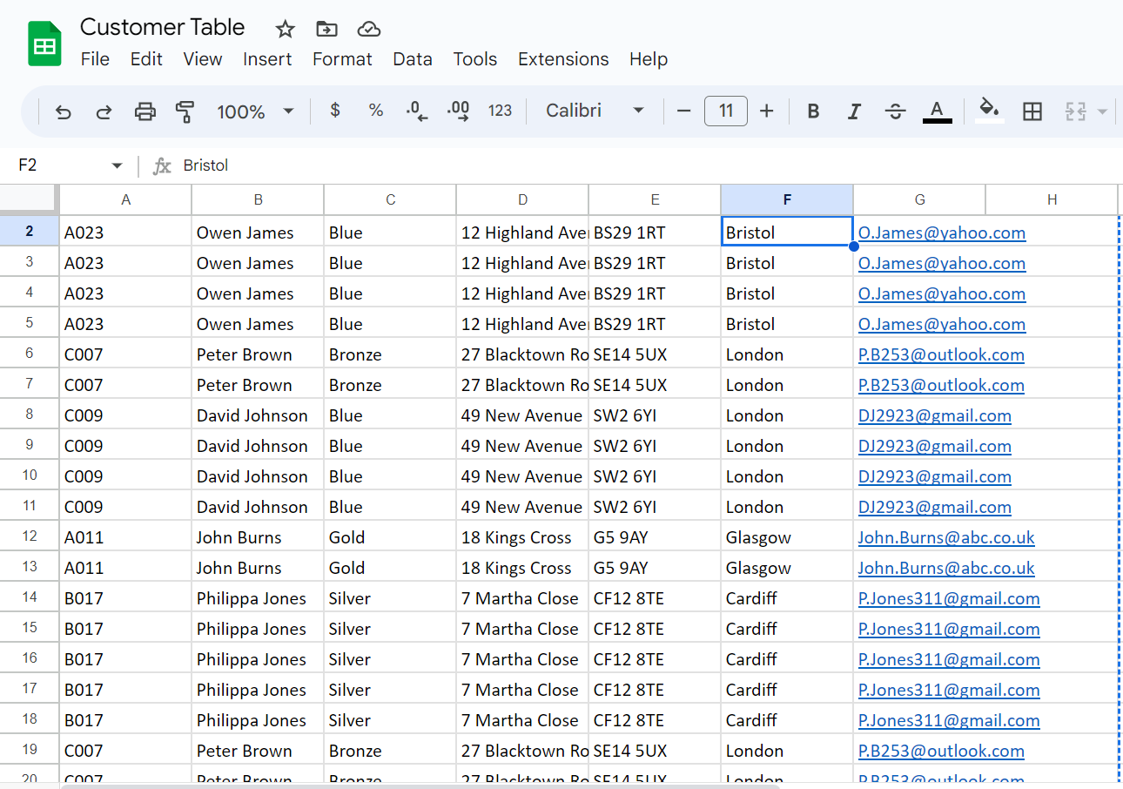

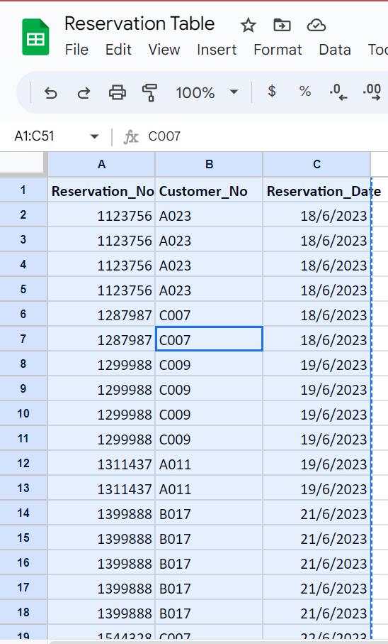

**Explanation:**

In the above table a reservation tables is created which demonstrates Normalization of the data. The primary key is the reservation number which is used for relationship among other tables and records.

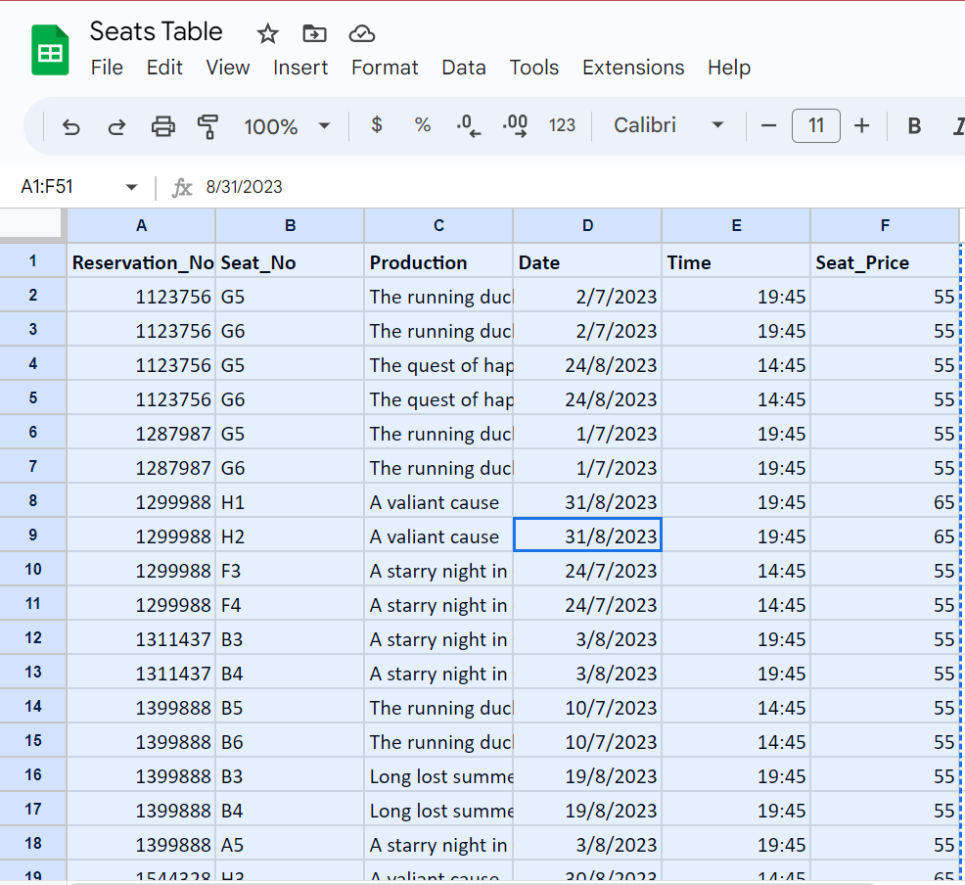

**Explanation:**

In the above table a seats tables is created which demonstrates Normalization of the data. In this table the reservation number is the foreign which is used in relation to the above table reservation table.

**ER Diagram:**  
  
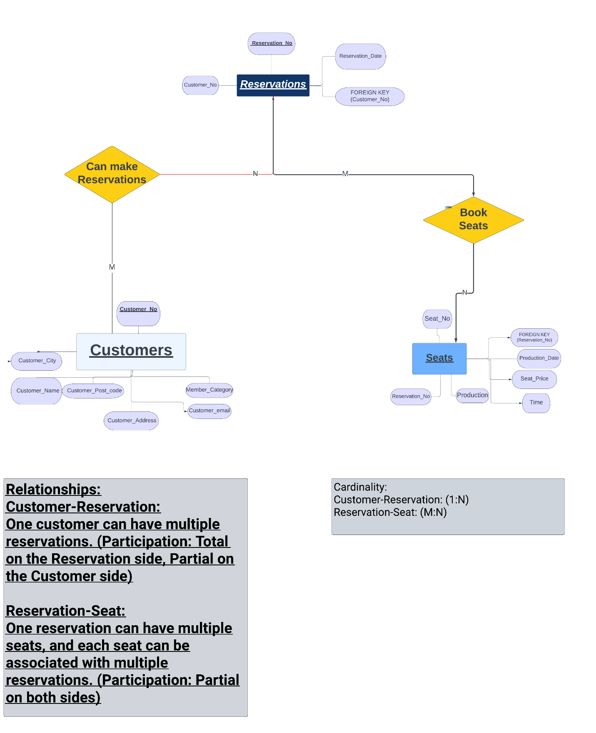

**Tables:**

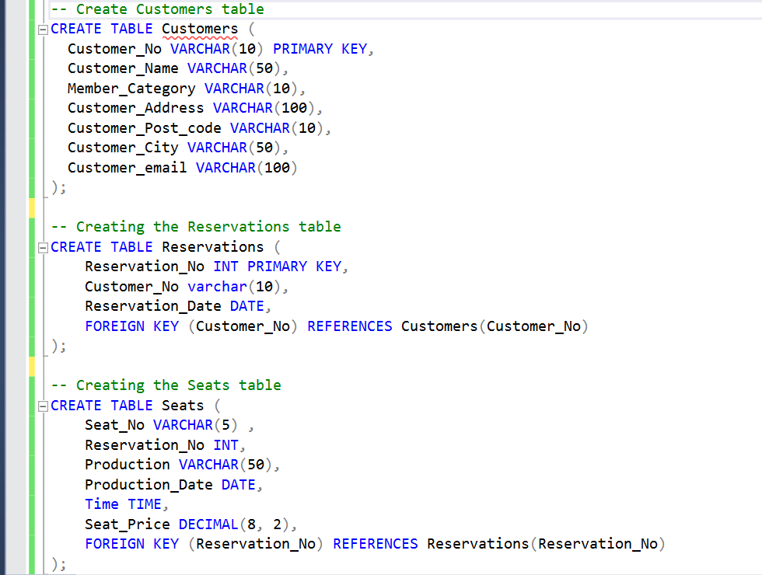

**Data Insertion:  
  
Table 1:  
  
**

**Table 3:  
  
**

**Data Populated in Database:**



